July’2026
Sandiip Kakadde
[Company name]

BrightSlide
Quick Start Guide
Table of Contents
1 Getting started 2
1.1 Download and install BrightSlide 2
1.3 Register your BrightSlide license 2
1.4 Enable Legacy Tools 4
2 Selecting and arranging objects 5
2.1 The last-selected reference object 5
2.2 Match the size of objects 5
2.3 Align objects to a slide 7
2.4 Swap the positions of two objects 8
2.5 Lock background objects 10
3 Formatting and layout 12
3.1 How the Multi-painter differs from Format Painter 12
3.2 Copy formats between objects 12

1 Getting started
This section covers downloading BrightSlide add-in from the BrightCarbon website, running the installer, registering the license, and locating the add-in on the PowerPoint ribbon.

1.1 Download and install BrightSlide
BrightSlide is a free add-in for Microsoft PowerPoint. It adds editing, formatting, and shortcut tools that PowerPoint doesn’t include out of the box.
After you install it, BrightSlide appears as a new tab on the PowerPoint ribbon.
- Go to https://www.brightcarbon.com/brightslide/
- Select Free download for Windows.
The installer file downloads to your machine.
- Open your downloads folder and double-click the BrightSlide installer file.
The Setup window displays.
- Read the license agreement and select I accept the agreement.
- Select Next for all succeeding dialog boxes to complete the installation.

All steps for installation and use are specific to Windows operating system.

1.3 Register your BrightSlide license
- Select Start, then select PowerPoint.
- Open a blank presentation, then select the BrightSlide tab on the ribbon.
- On the top left, select Register to Activate.
The BrightSlide – Register Account dialog displays.

- Enter the required details and then select the “I agree to the terms of the end user license” checkbox.

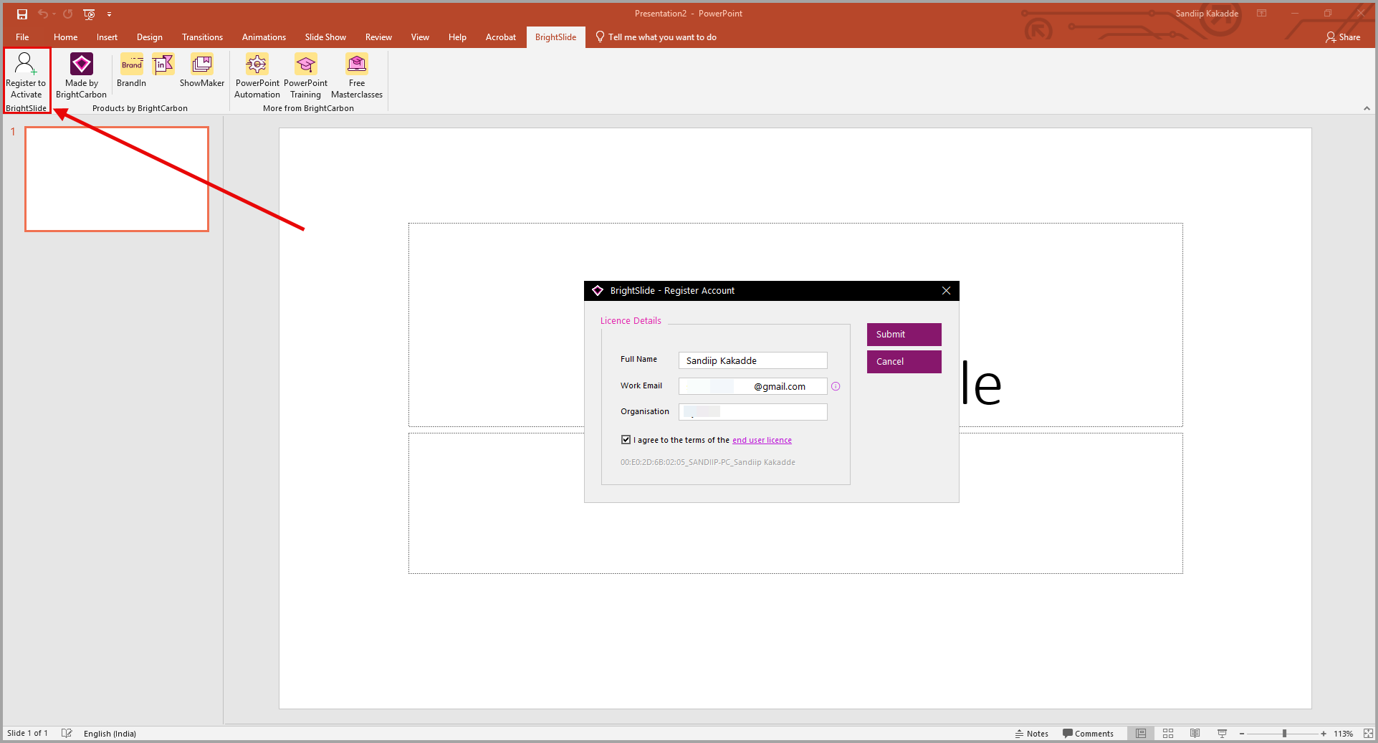

- Select Submit.
A verification email is triggered to your registered email address.
- Open the email and verify your email address, then return to PowerPoint and select Finish.
A message displays confirming your license has been successfully activated.
- Select OK.

1.4 Enable Legacy Tools
- On the BrightSlide tab, select Settings & Help > Settings > Ribbon Setup.
The Ribbon Setup dialog displays.
- Select the Legacy Tools checkbox.

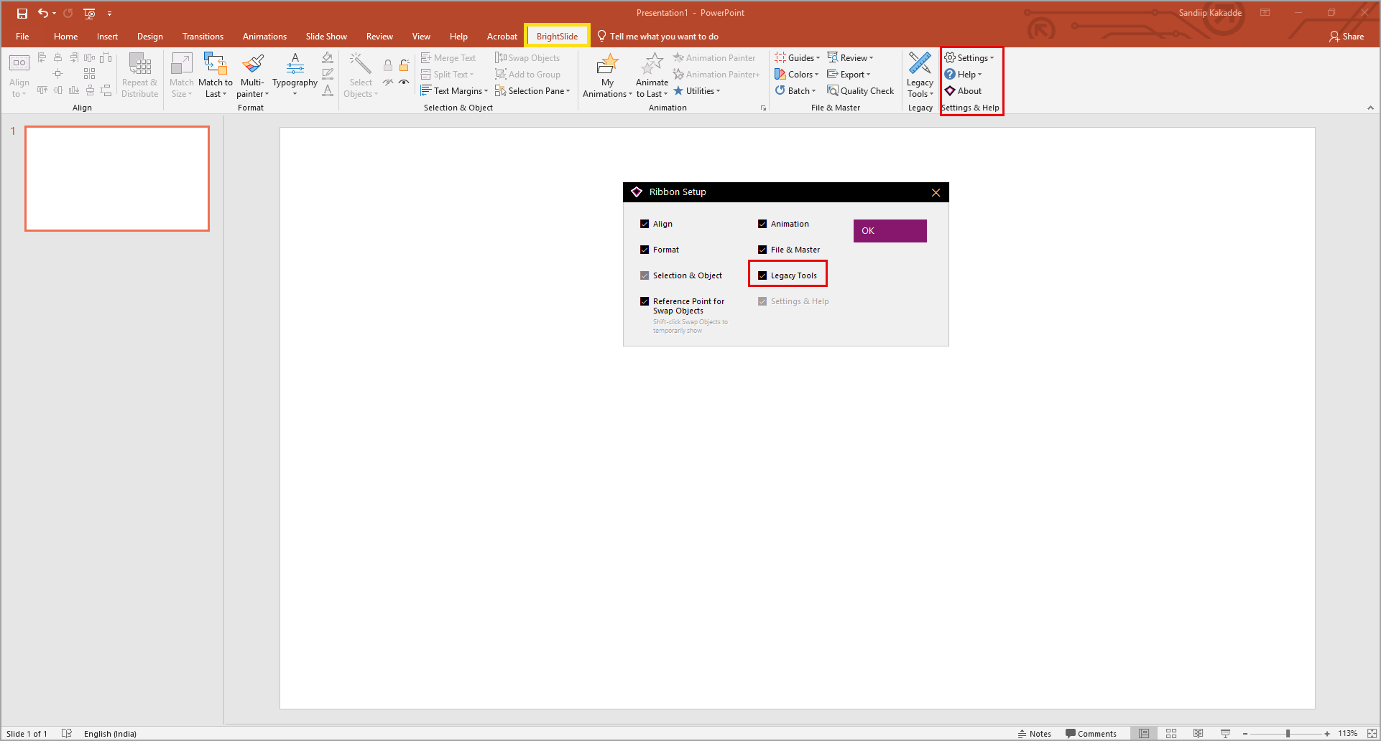

- Select OK.

2 Selecting and arranging objects
This section covers matching size, aligning, swapping, and locking objects on a slide including how the last-selected object acts as a reference for size matching.

2.1 The last-selected reference object
When you select multiple objects on a slide, BrightSlide treats the last-selected object as the reference object. The other objects inherit its attributes (for example, fill color, outline color, outline weight, shape type, font size etc.).
The default setting in BrightSlide uses the last object as the reference. This setting affects the following features in BrightSlide:
- Align to Reference Object
- Add to Group
- Match Size
- Match to Reference Object
- Animate to Reference Object
To change this setting, in the PowerPoint menu bar go to the BrightSlide tab, and select Settings & Help > Settings > Set Reference Object.

2.2 Match object sizes
- In PowerPoint, navigate to the slide objects for which you want to match the size.
- Use the Shift key on your keyboard and select the objects for which you want to match the size.

- In the menu bar on the BrightSlide tab under Format ribbon, select Match Size and choose Match Size from the dropdown menu.

In the example below, you select the objects A, B, and C, for them to match the size.

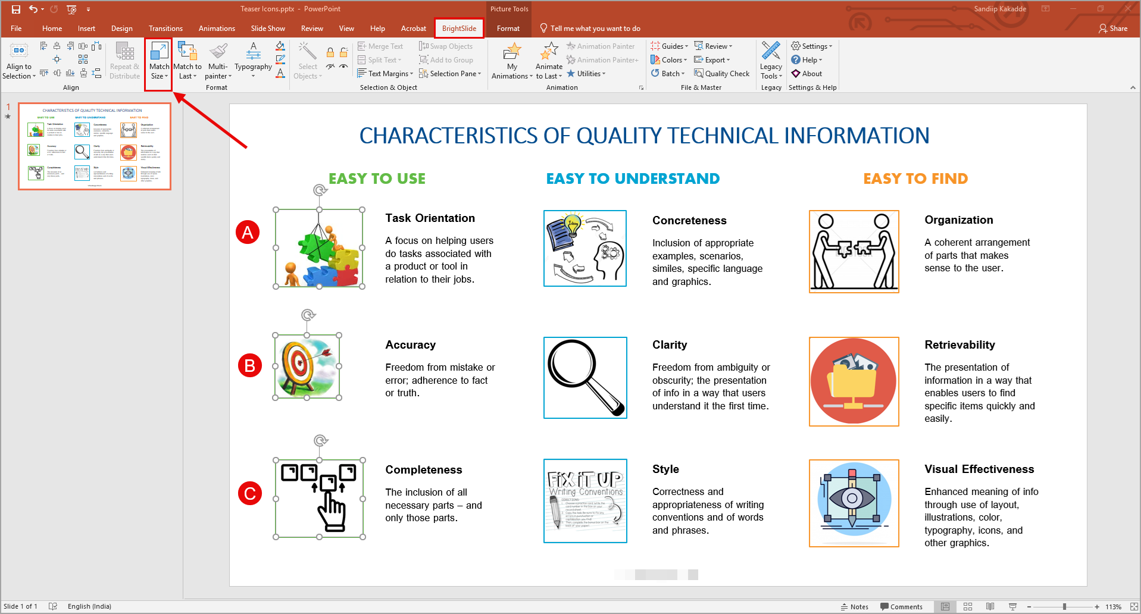

- Similarly, select Match Width and Match Height from the dropdown menu to match the height and width of the objects.

2.3 Align objects to a slide

- In PowerPoint, navigate to the slide containing the object(s) you want to align.
- In the menu bar on the BrightSlide tab under Align ribbon, select Align to Slide and choose one from the following:
- Align to Selection: Aligns objects to the edges of your current selection. This is PowerPoint’s default alignment mode.
- Align to Last Selected: Aligns all selected objects to a single reference object, the last one you selected. For more information, see the last-selected reference object.
- Align to Guides: Aligns each object to the nearest guide. Available on Windows OS only. For more information, see Guides.
- Align to Slide: Aligns objects to the slide edges. When only one object is on the slide, PowerPoint uses this mode by default.
- Remember Between Sessions: Saves your chosen alignment mode so it persists each time you open PowerPoint.
- (Optional) In the Align ribbon, you can align the objects by selecting from the following icons:

Icon | Description
 | Align the objects to the left, center, or right of the slide.
 | Align the objects to the top, middle, or bottom of the slide.
 | Align two or more objects to the center and middle by combining align center and align middle with one select.
 | Align in a grid formation by selecting multiple objects (for example, icons) to make them equidistant within the defined slide space.  Note, different-sized objects are not supported by this feature.
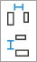 | Align the objects by precisely distributing them by spacing. The objects get distributed equally from the reference object (first selected or last selected based on your setting) that is highlighted.  You can adjust the space between the objects using the arrow keys on your keyboard, the slider dialog displayed, or by typing in an exact value.
 | Split a single object, or group, into evenly sized and spaced copies of itself that are placed inside the boundaries of the original object.  You can choose the number of columns and rows, and set the gutters or width/height to your liking.

2.4 Swap two objects
- Go to the slide that contains the two objects you want to swap.
- Hold Shift and select both objects.

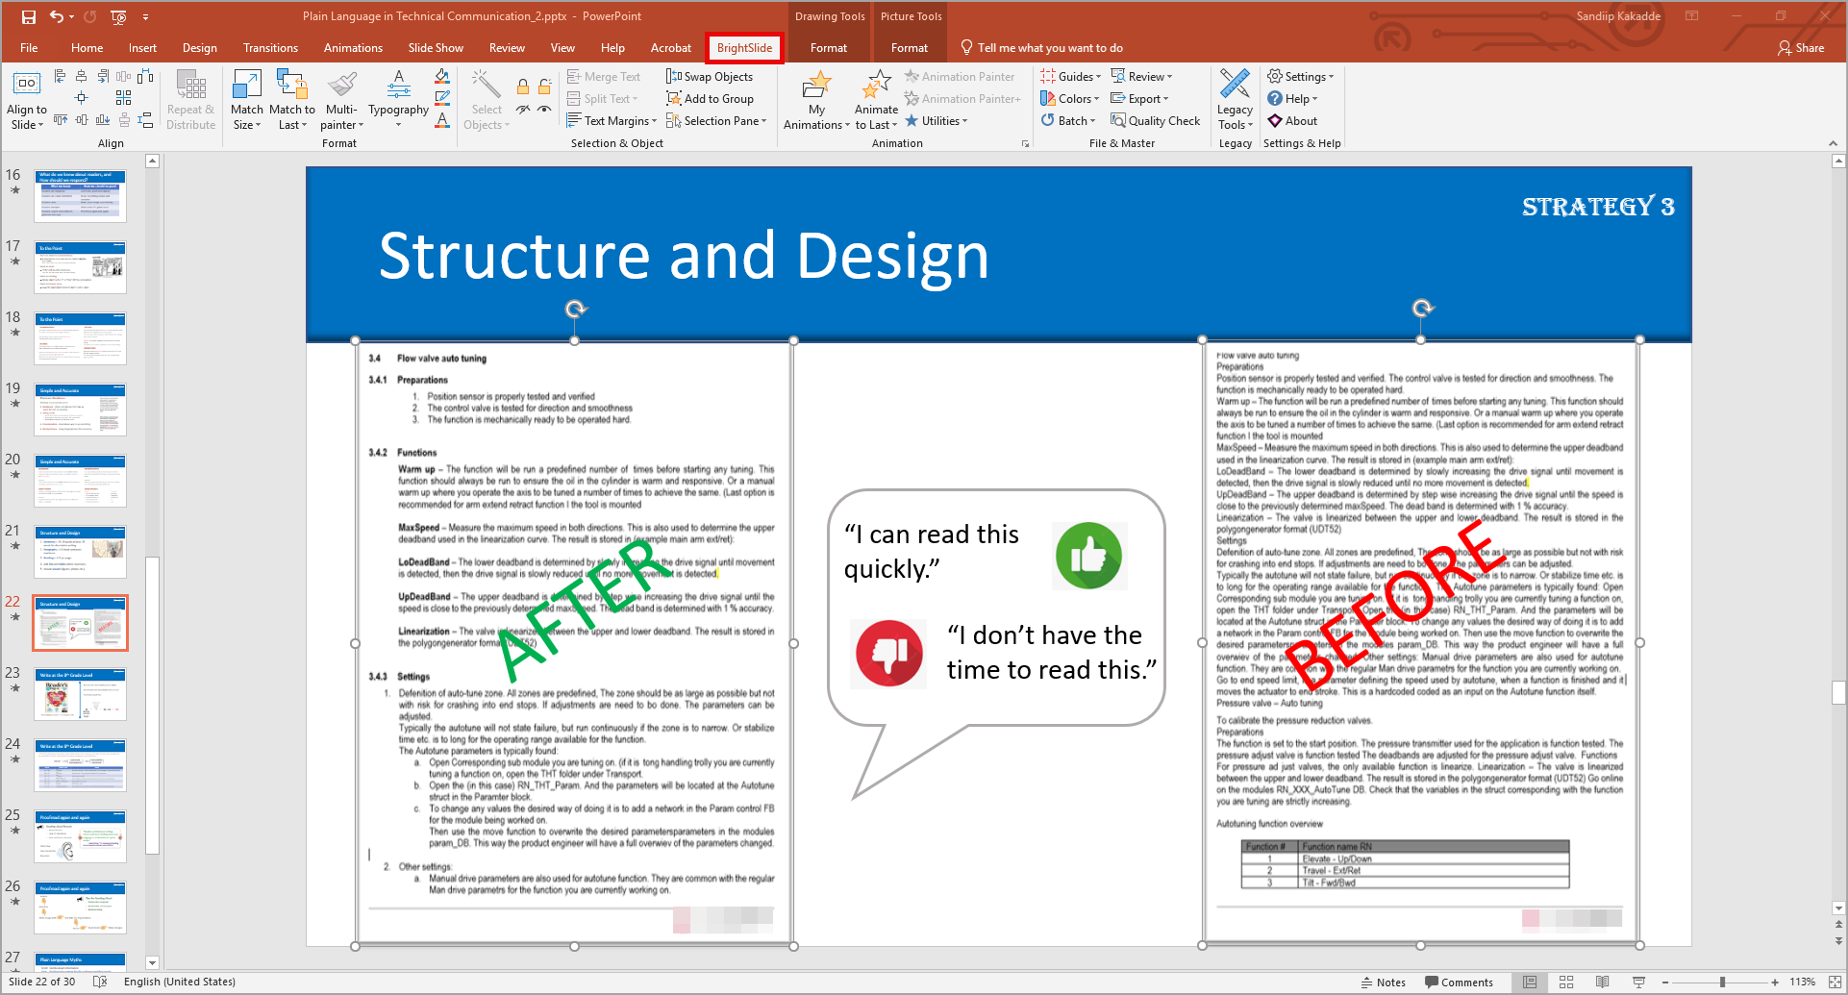

- On the BrightSlide tab under Selection & Object ribbon, select Swap objects.
The two objects switch positions exactly without the need to manually drag and adjust the alignment.

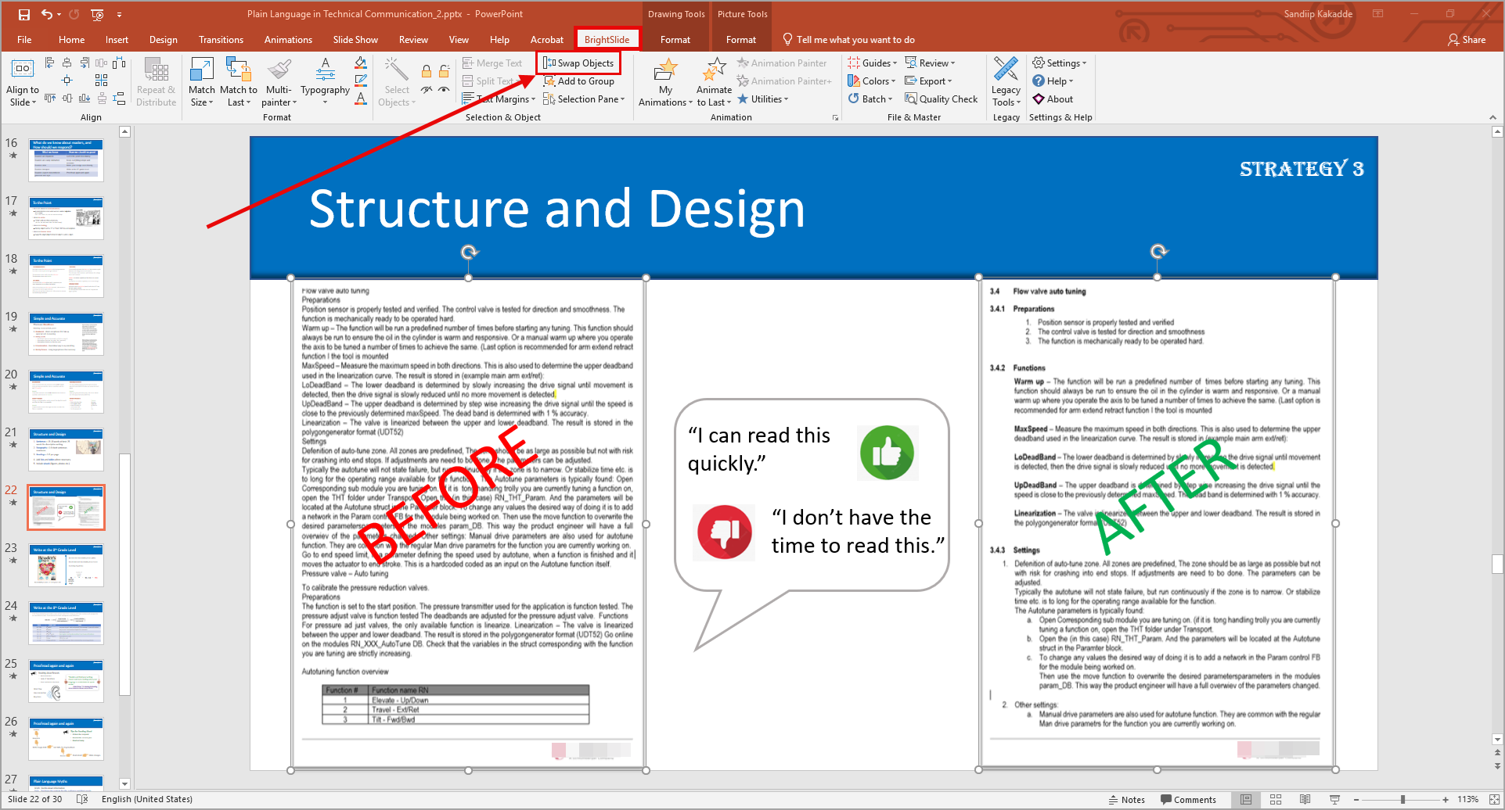

2.5 Lock background objects

- Select the object you want to lock (for example, a background image).
- On the BrightSlide tab, in the Format ribbon, select the Lock icon.
The object stays visible but can’t be selected or moved.

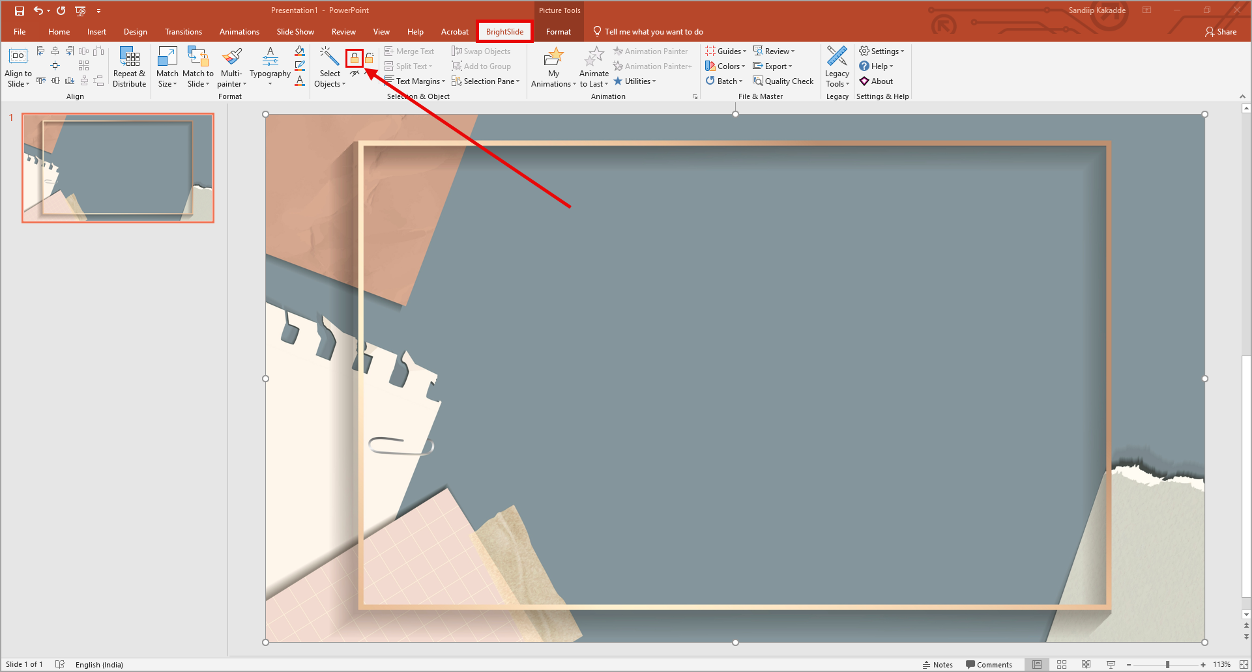

- Make your edits on the slide.
You can add, move, or resize other objects without disturbing the locked element.

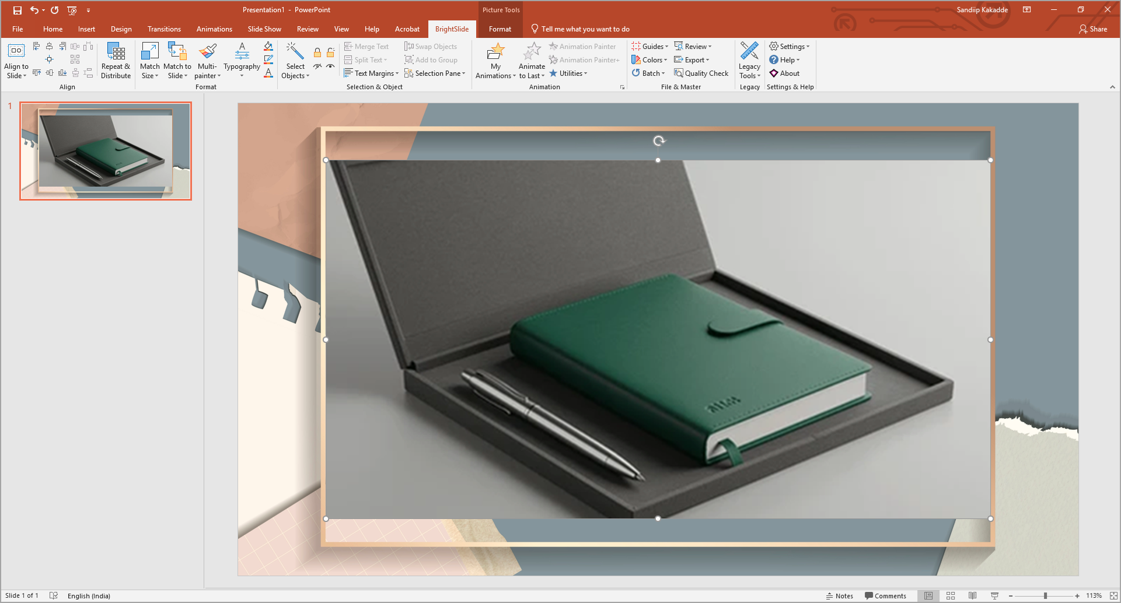

- When you’re done, go to the Format ribbon and select the Unlock icon to release all locked objects on the slide.

3 Formatting and layout

3.1 How the Multi-painter differs from Format Painter
Multi-painter allows you to copy and apply properties (size, position, formatting, adjustments, and animations) from one object to another. The default sticky mode lets you copy properties across slides and presentations. With no selection, the painter picks up slide properties itself such as size and position which is a handy feature when filling an entire slide with an image.

3.2 Copy formats between objects
- In PowerPoint, navigate to the slide where you have the objects you want to format.
- Select the object whose format you want to copy to another object.
- On the BrightSlide tab under Format ribbon, select Multi-painter.
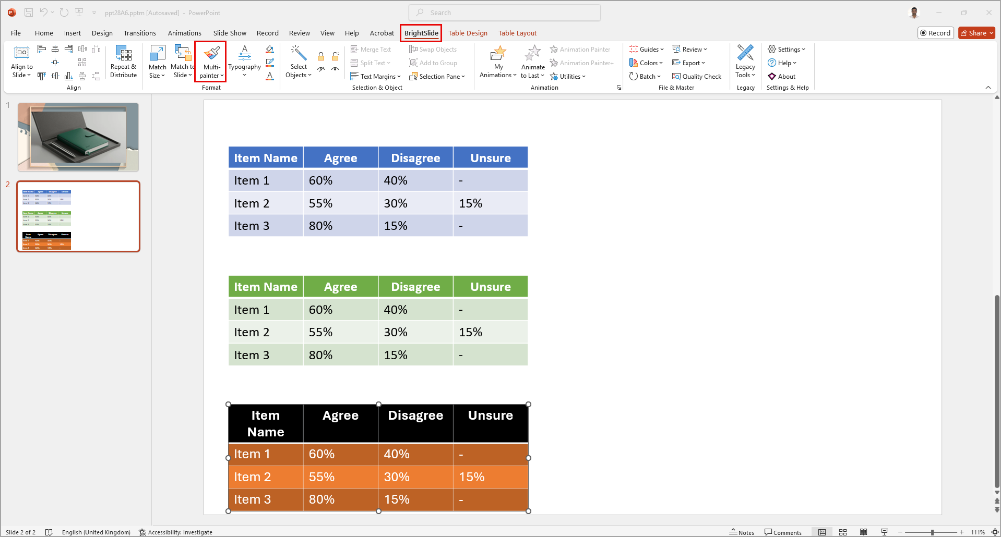

- Select the object to which you want to apply the copied formatting.
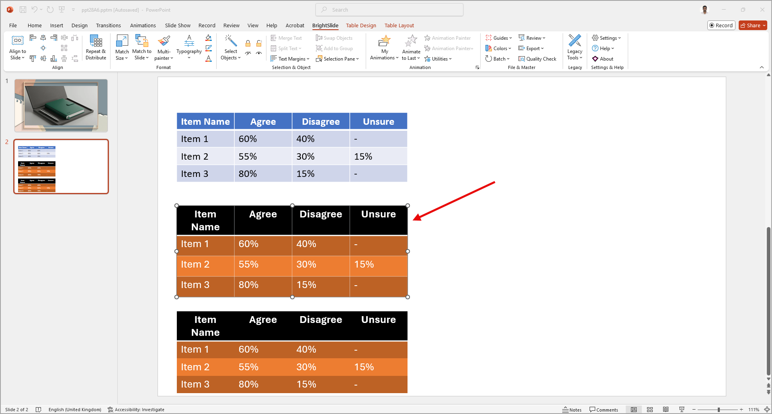
You can use the Multi-painter feature to copy formatting across charts and images as well.

